Minikube installation in local machine

To install minikube we need

- Docker desktop installed
- Vm installed
- Install minikube using powershell

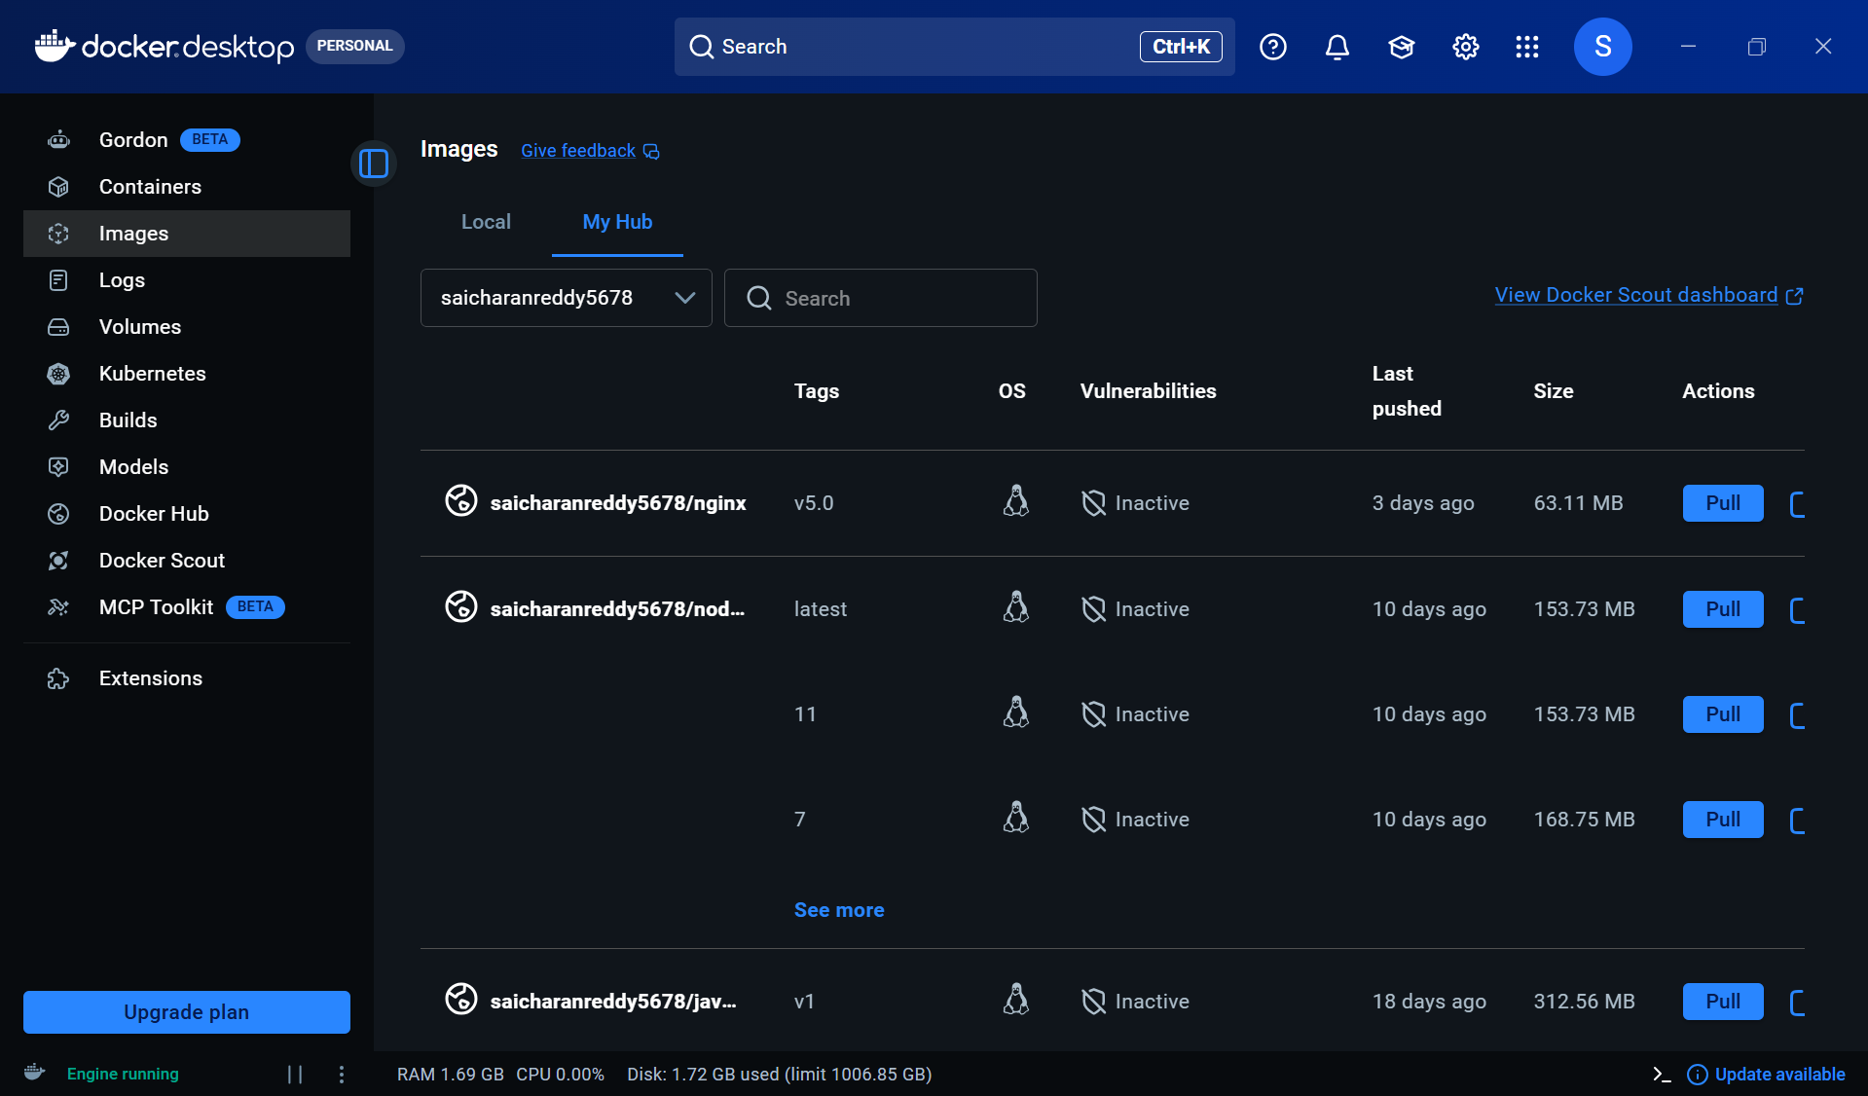

Docker desktop has already been installed in local machine

Also installed vm and can be seen in systeminfo throw ps

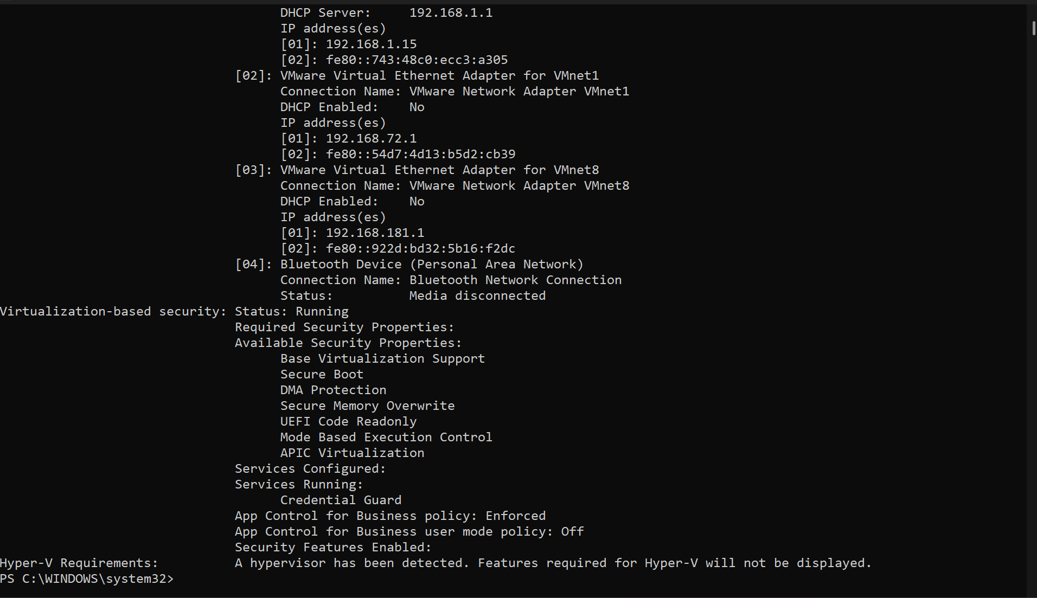

Now installing through minikube from website through powershell

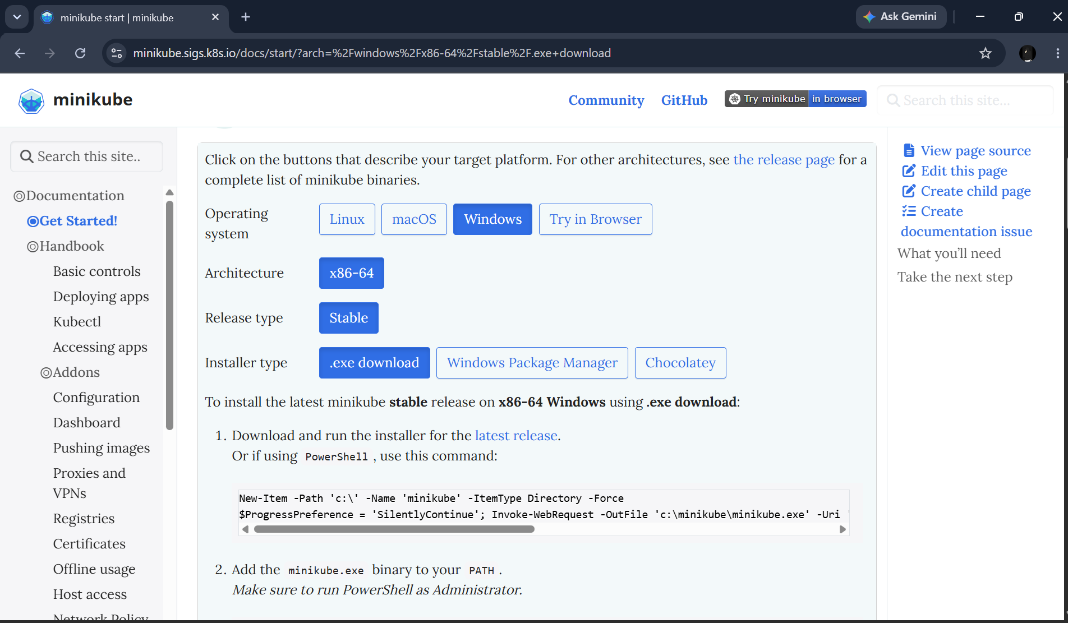

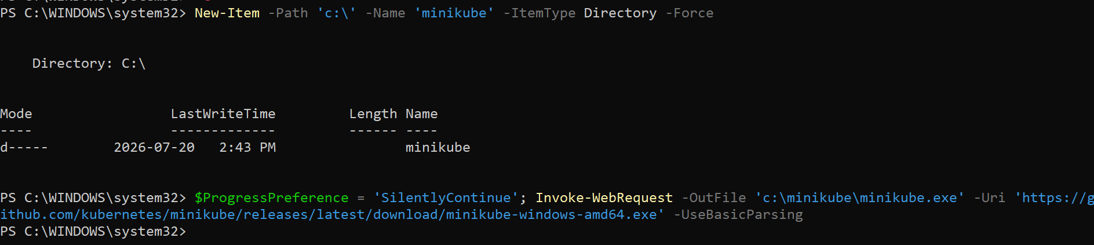

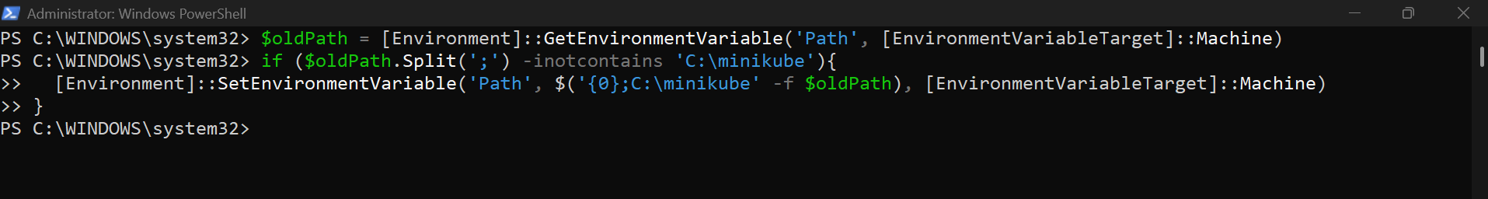

After giving the above commands

Close the power shell and reopen

Then run minikube start
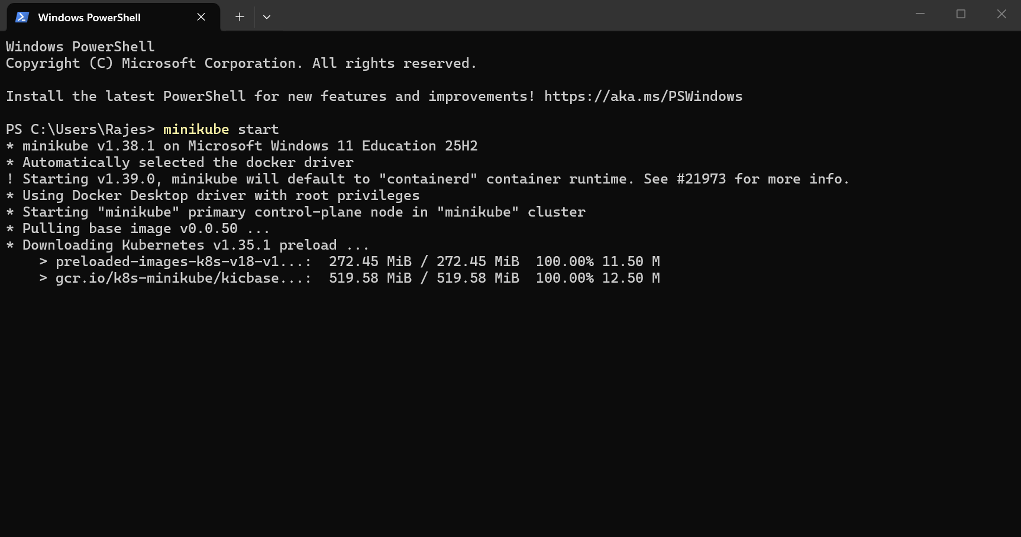

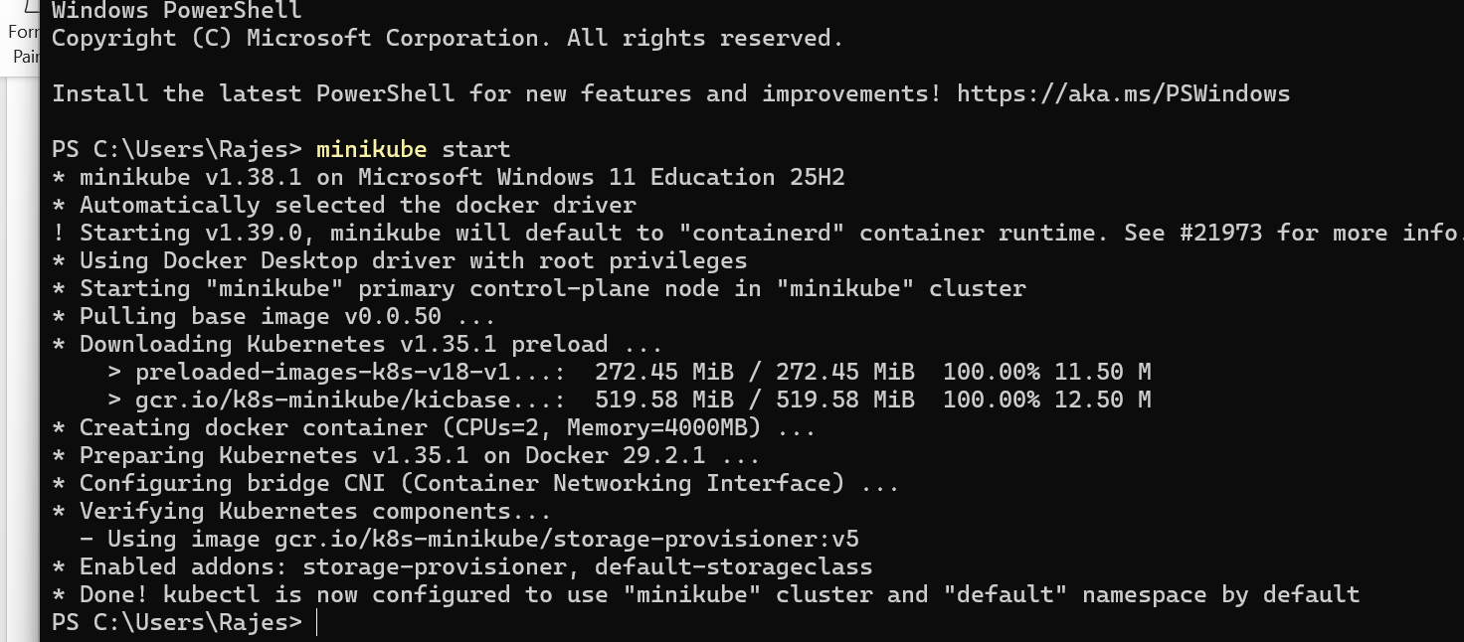

And minikube has been started

And we can see the minikube ip

and also we can ssh into the minikube

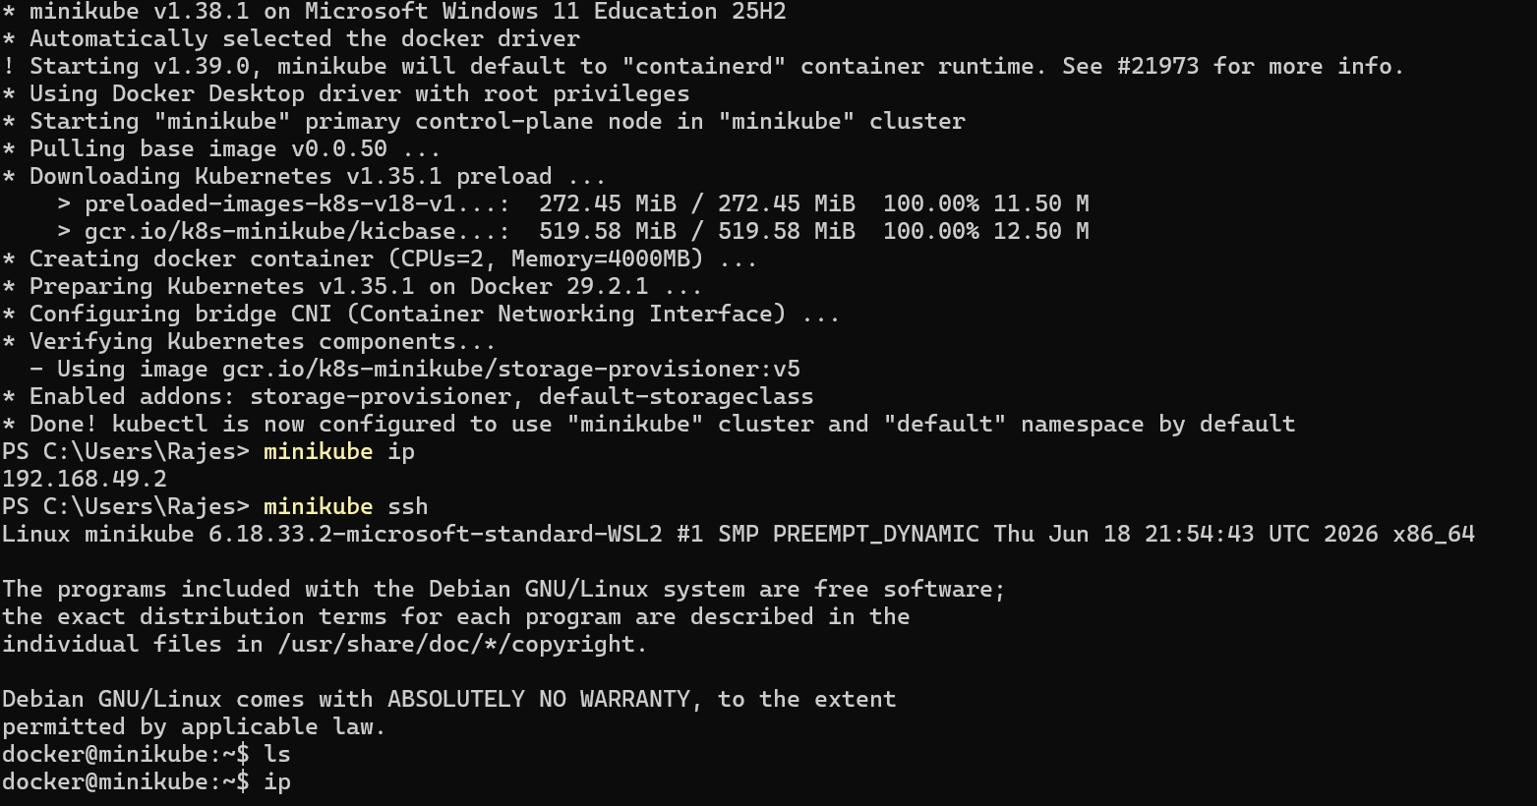

We can also see through dashboard
Use :-
Minikube dashboard

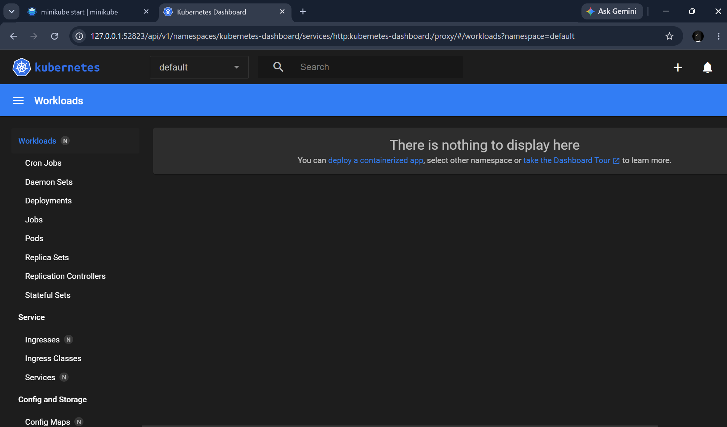

To check ip use minikube ip
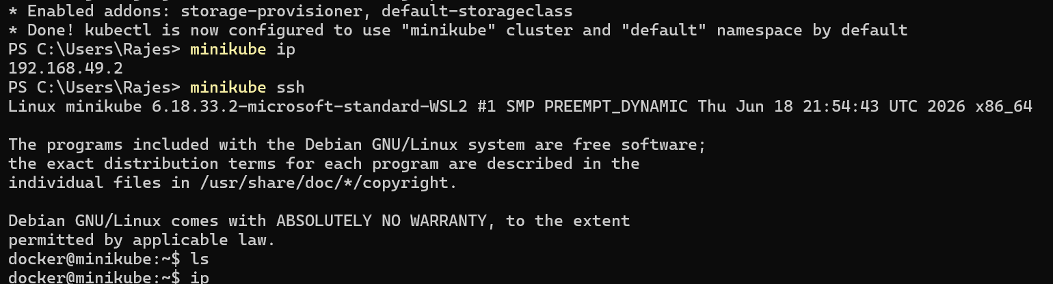

Setup k8s master and two worker nodes on ubuntu

Setting up k8s master and two worker nodes in ubuntu instance

Creating 3 new instances and setting one insatnce as master and another two as worker nodes

Changin the hostname for all instances to understand easily
Vi /etc/hostname
or
Hostnamectl set-hostname name
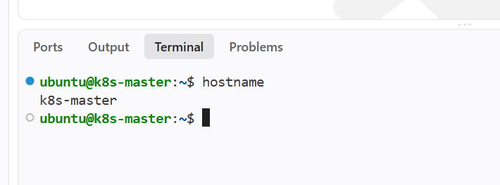

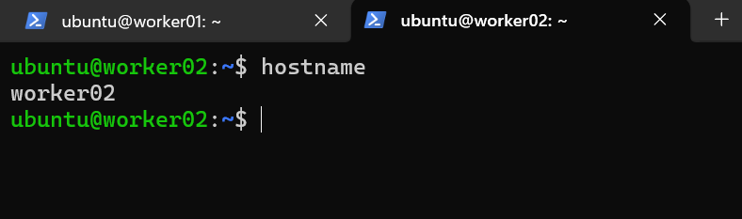

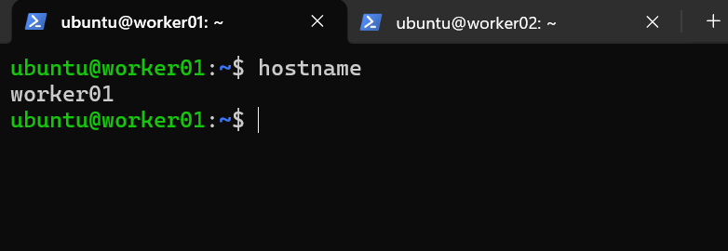

Then add the private ips of worker nodes in master node

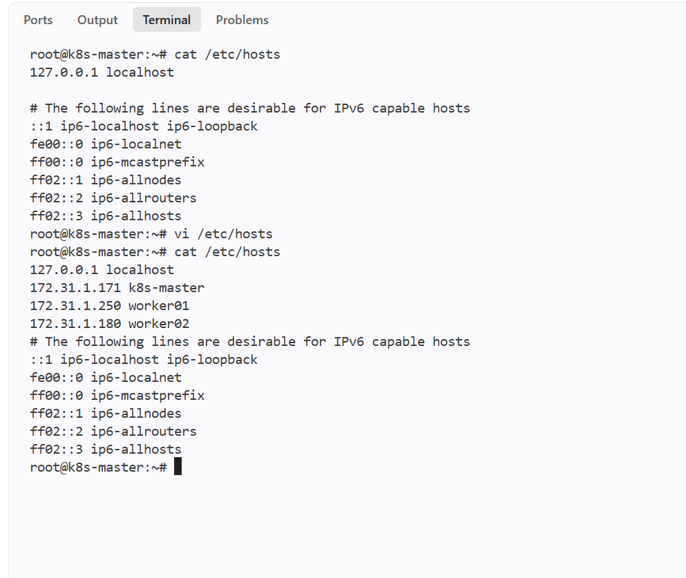

Then setting up ipv4 bridge on all nodes

cat <<EOF | sudo tee /etc/modules-load.d/k8s.conf
overlay
br_netfilter
EOF

sudo modprobe overlay

sudo modprobe br_netfilter

# sysctl params required by setup, params persist across reboots
cat <<EOF | sudo tee /etc/sysctl.d/k8s.conf
net.bridge.bridge-nf-call-iptables = 1
net.bridge.bridge-nf-call-ip6tables = 1
net.ipv4.ip_forward = 1
EOF

# Apply sysctl params without reboot
sudo sysctl --system

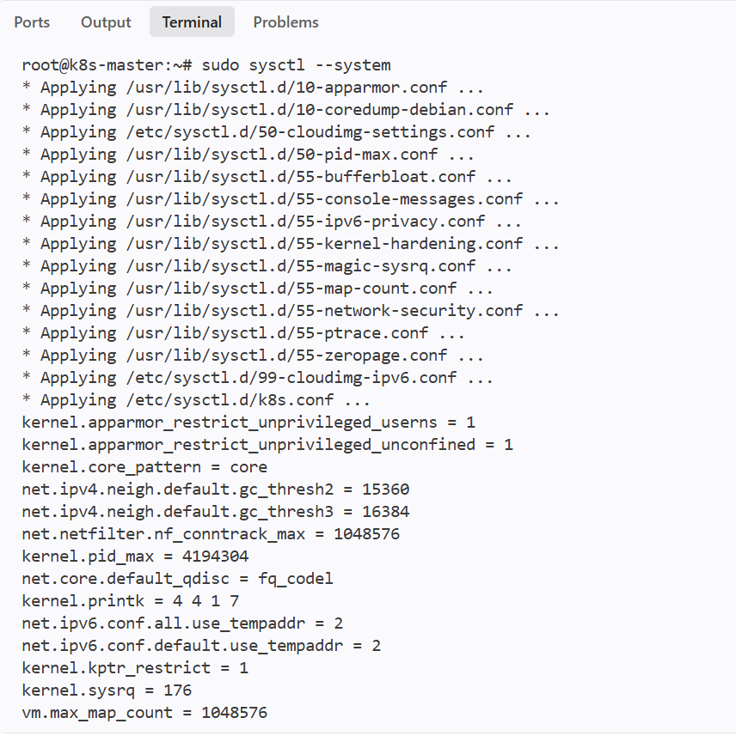
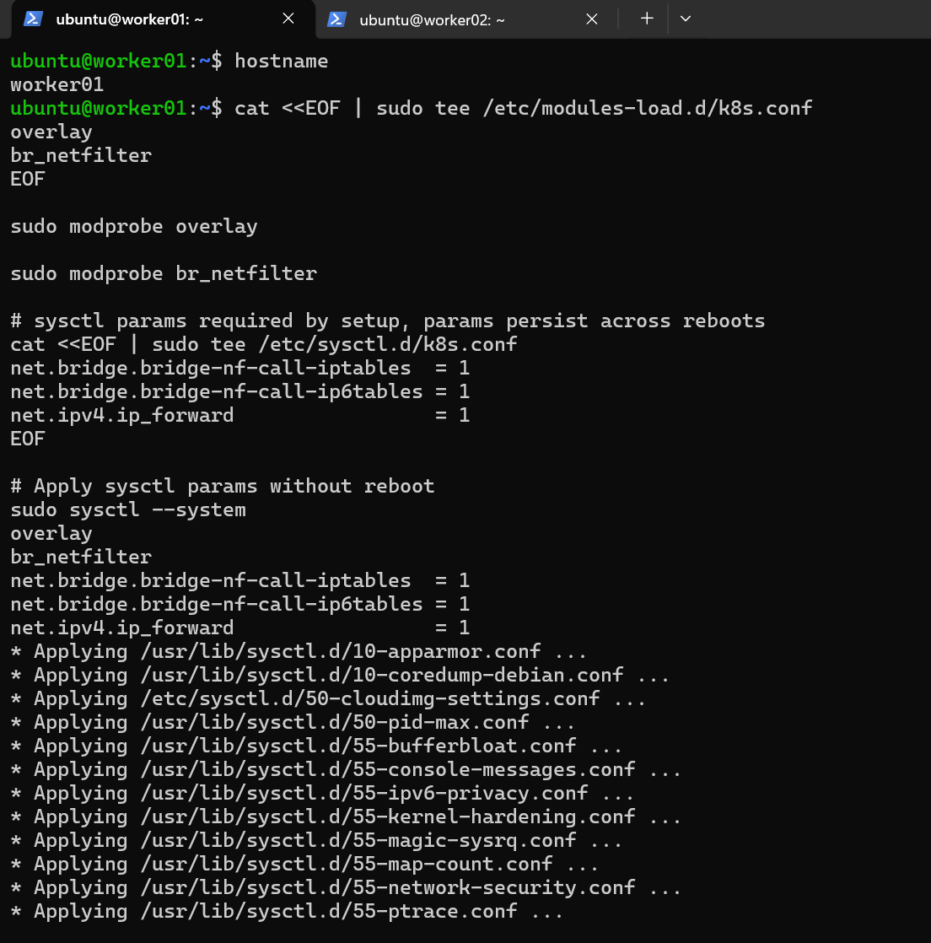

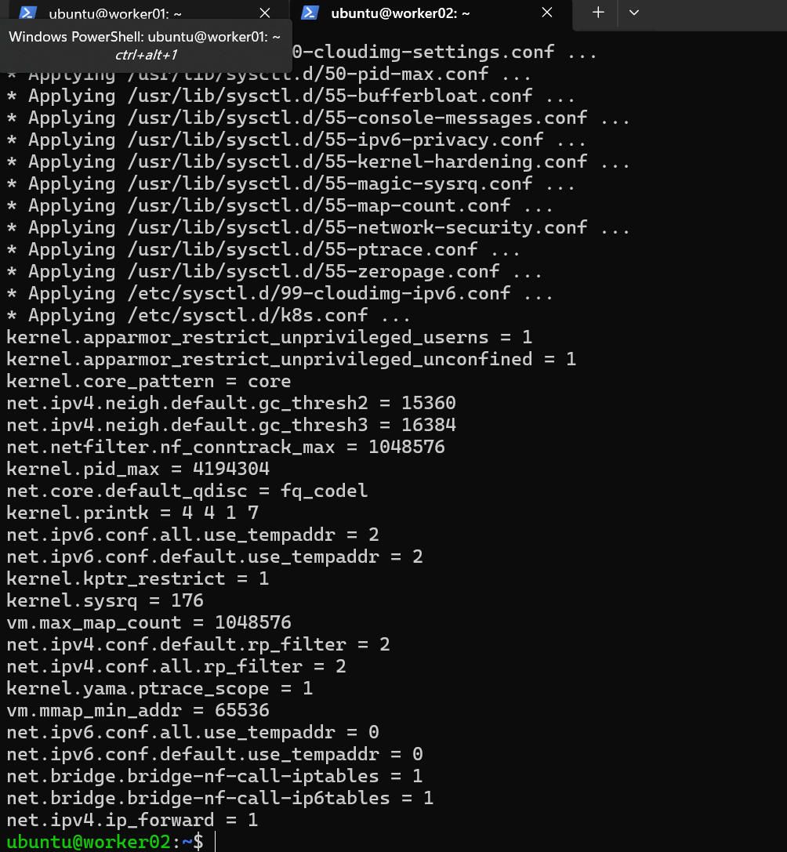

Done on 3 nodes

Install kubelet, kubeadm, and kubectl on each node

sudo apt-get update

sudo apt-get install -y apt-transport-https ca-certificates curl gpg

curl -fsSL https://pkgs.k8s.io/core:/stable:/v1.29/deb/Release.key | sudo gpg --dearmor -o /etc/apt/keyrings/kubernetes-apt-keyring.gpg

echo 'deb [signed-by=/etc/apt/keyrings/kubernetes-apt-keyring.gpg] https://pkgs.k8s.io/core:/stable:/v1.29/deb/ /' | sudo tee /etc/apt/sources.list.d/kubernetes.list

sudo apt-get update

sudo apt-get install -y kubelet kubeadm kubectl

sudo apt-mark hold kubelet kubeadm kubectl

Installing docker

sudo apt install docker.io

sudo mkdir /etc/containerd

sudo sh -c "containerd config default > /etc/containerd/config.toml"

sudo sed -i 's/ SystemdCgroup = false/ SystemdCgroup = true/' /etc/containerd/config.toml

sudo systemctl restart containerd.service

sudo systemctl restart kubelet.service

sudo systemctl enable kubelet.service

Then

Initialize the Kubernetes cluster on the master node

On MASTER NODE:-
sudo kubeadm config images pull

sudo kubeadm init --pod-network-cidr=10.10.0.0/16
mkdir -p $HOME/.kube
sudo cp -i /etc/kubernetes/admin.conf $HOME/.kube/config
sudo chown $(id -u):$(id -g) $HOME/.kube/config

Configure kubectl and Calico
kubectl create -f https://raw.githubusercontent.com/projectcalico/calico/v3.26.1/manifests/tigera-operator.yaml

curl https://raw.githubusercontent.com/projectcalico/calico/v3.26.1/manifests/custom-resources.yaml -O

sed -i 's/cidr: 192\.168\.0\.0\/16/cidr: 10.10.0.0\/16/g' custom-resources.yaml
kubectl create -f custom-resources.yaml

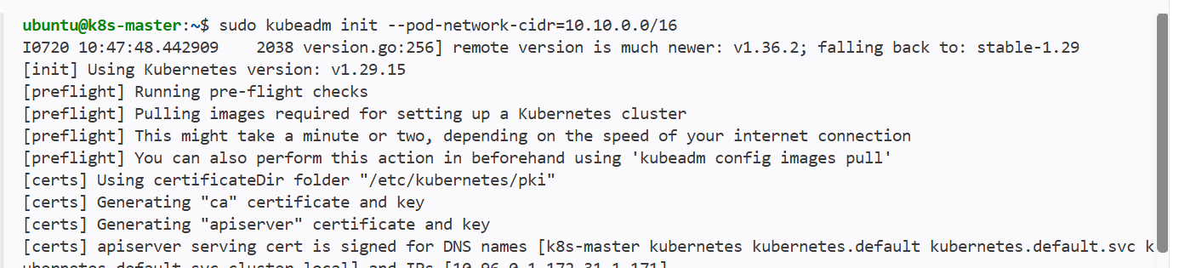

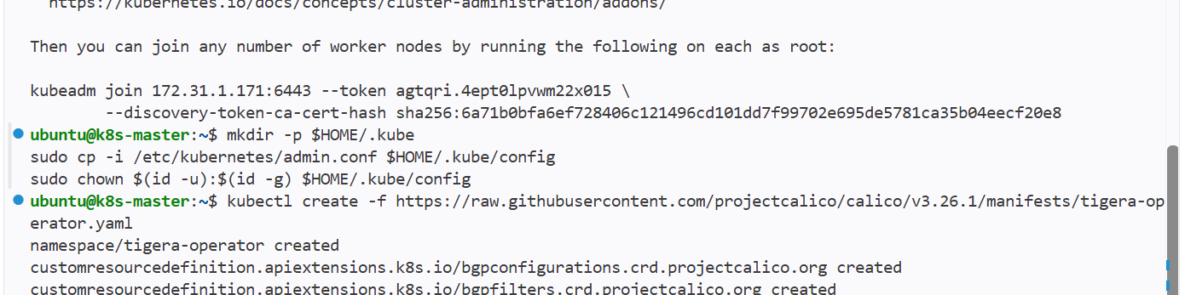
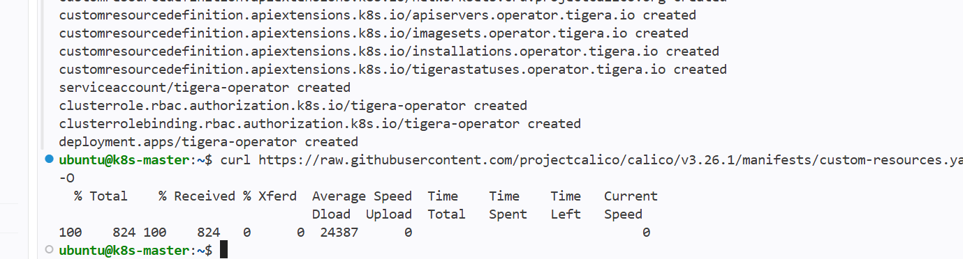

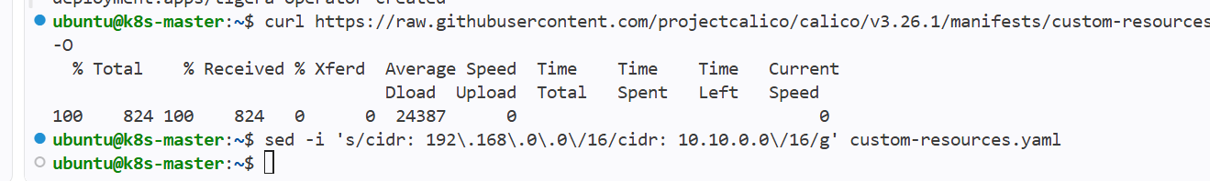

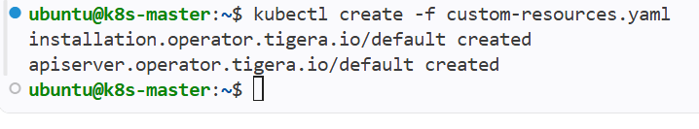

Add worker nodes to the cluster

This is to join the node to the cluster that has generated when installing in master node
kubeadm join 172.31.1.171:6443 --token agtqri.4ept0lpvwm22x015 \
--discovery-token-ca-cert-hash sha256:6a71b0bfa6ef728406c121496cd101dd7f99702e695de5781ca35b04eecf20e8

Use this in two worker nodes so that it will add to the master node

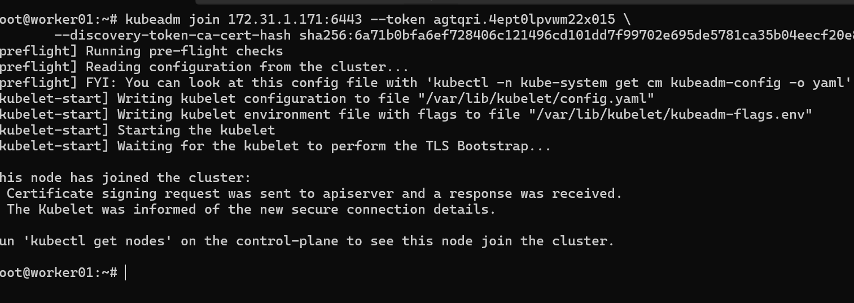

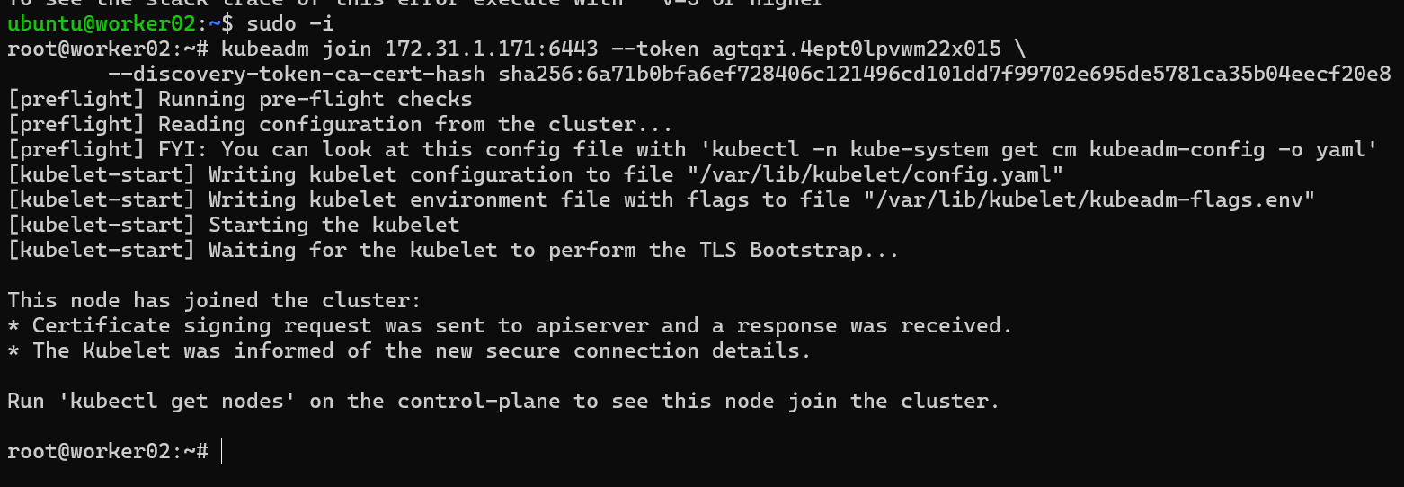

Verify the cluster and test
kubectl get nodes

If it says error and connection to server was refused
Then export the kubeconfig file

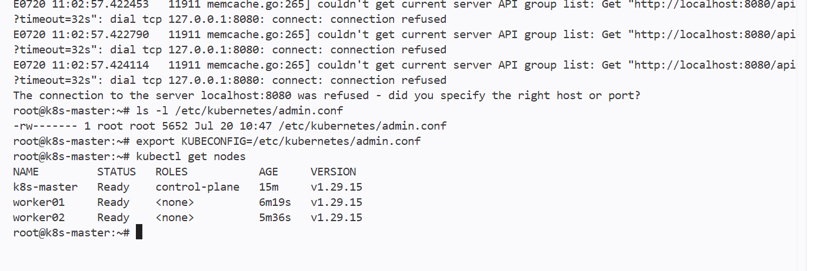

Then we can see the nodes in master node

Run one nginx pod

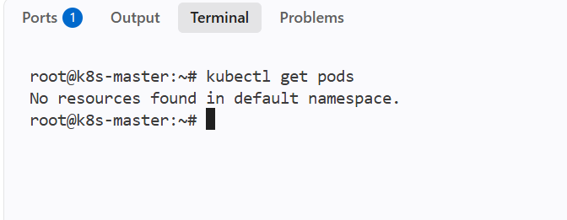

Now there are no pods running

We will be creating a new pod using

Kubectl run nginxpod --image=nginx

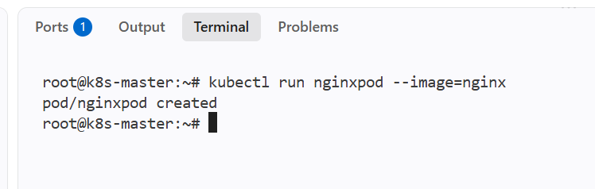

New pod has been created

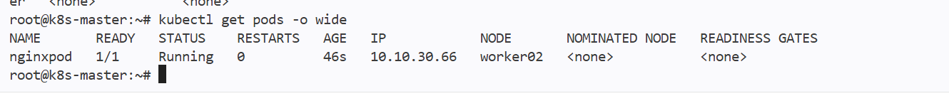

We can also on which worker that pod has been created

If I want to expose my pod then I will use service
Or
Delete the pod and create a new pod with port mapping

I have deleted the old pod

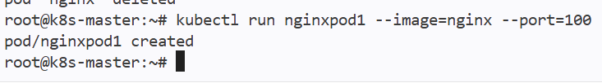

And can see the port number for pod

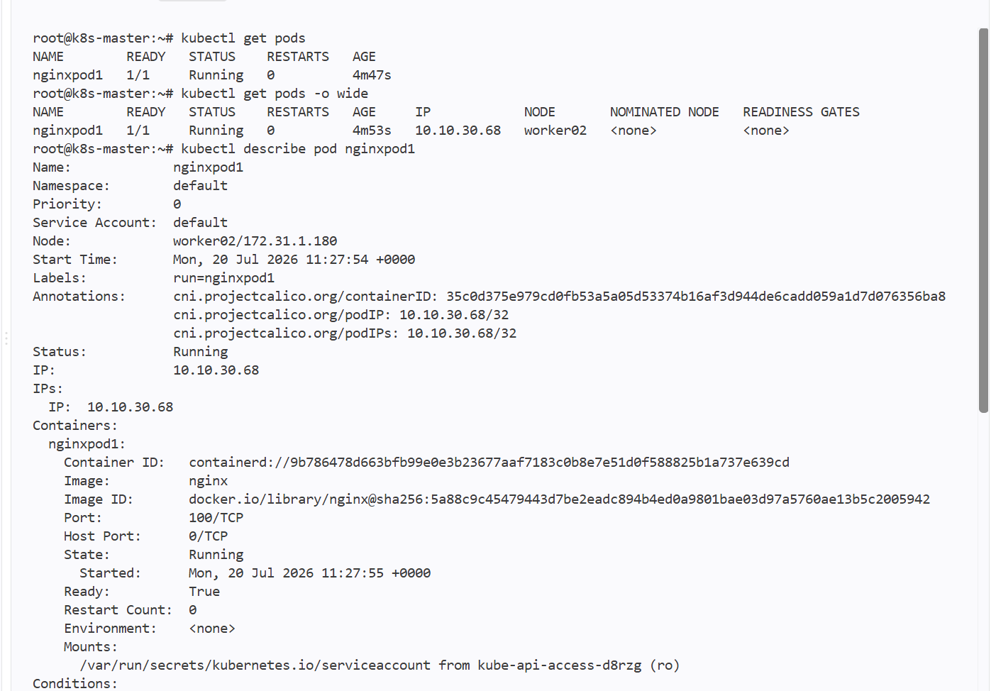

Then we can see the Pod containerPort metadata 100 as I have given through command but when I create a service if I have given another port the pod will be expose on service port

Now in order to expose it to the internet we need to add service to the pod

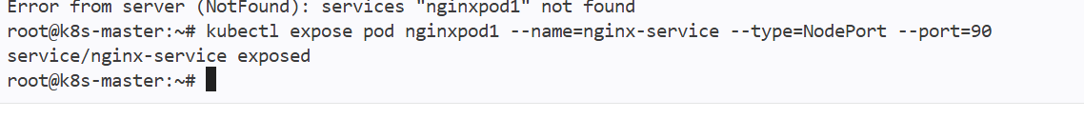

I have created a service and exposed the pod on 80

Kubectl expose pod podname --name=newservicename --type=NodePort --port=80

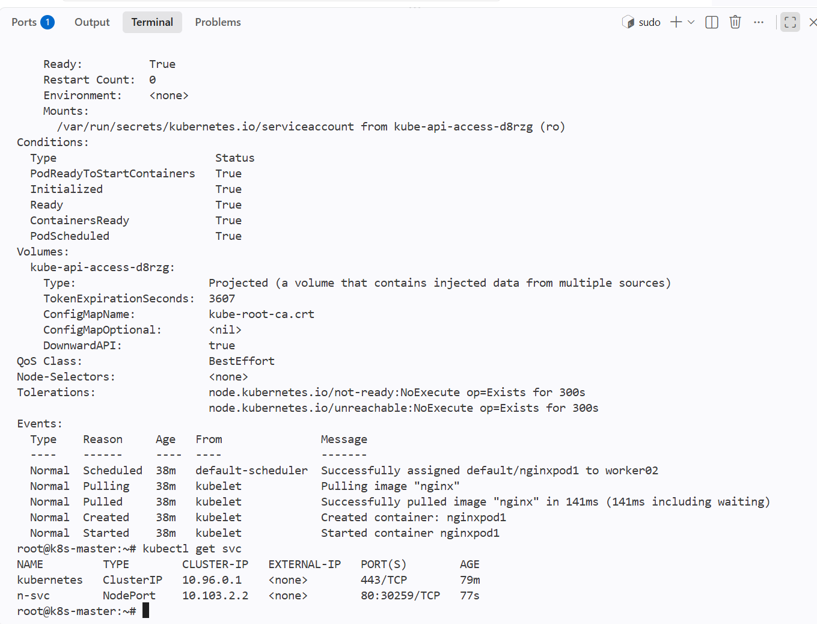

Now in browser see through second worker ip and nodeport port num ber that is 30259



